**Project Four- Import Data and Queries**

For this Assignment, you will convert an Excel file, with three pages, to a database, with three tables.

**Project four - Excel** is your work file for this project. You can find it also in the Student Resources folder.

Three Excel Work Pages will be converted to three DB Tables and saved as APPOINTMENT, INVOICE, and BILLING

**BOOK1** will be saved as **APPOINTMENT**

**BOOK2** will be saved as **INVOICE**

**BOOK3** will be saved as **BILLING**

**Assignment’s STEPS:**

1. **How to import an excel spreadsheet into a Table**

* Open a new database and save it as Project04_Your last name
* Go to folder Project folder, locate **Project Four – Excel file** and Download the Excel file.

**Note:** You better to download the excel file to the document library. Or you may download it to your desktop or an external disk to work with.

* Follow the instructions below

1. In the new DB,click **External Data**
2. In the **Import & Link section**, click **Excel**

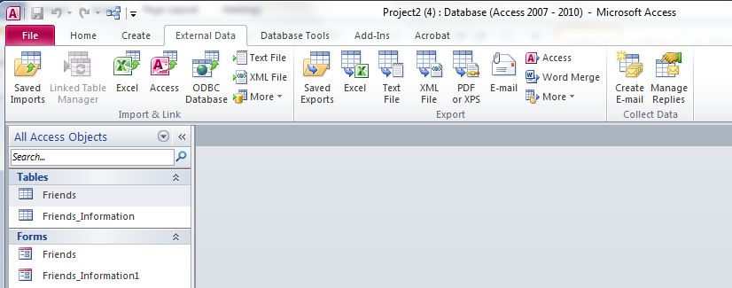

1. This should open the **Get external Data – Excel Spreadsheet dialog box** (see below screen shot)

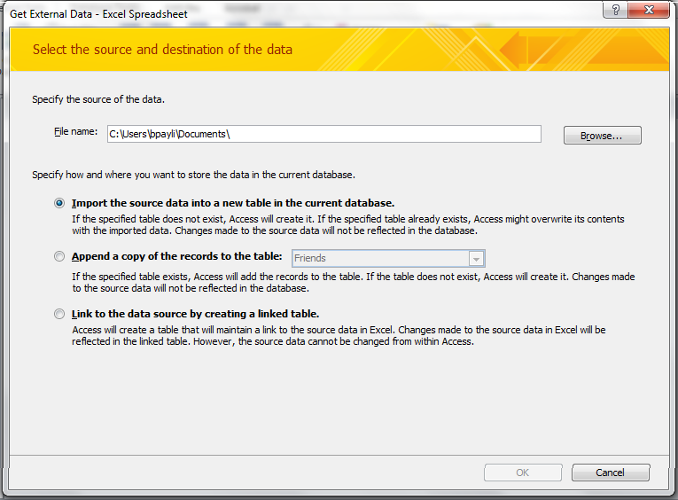

1. In the **Get External Data** - **Excel Spreadsheet**, click **browse**.
2. Locate the folder that contains the excel files you want to import. Select **Project Four - excel** file.
3. **Note:** You better to download the excel file. It will be under the document library. Or you may download it to your desktop or an external disk to work with.
4. Click **Open** after selecting the file.
5. Then, **click OK**
6. Select the first file to conver to a table, click on ‘Next’.

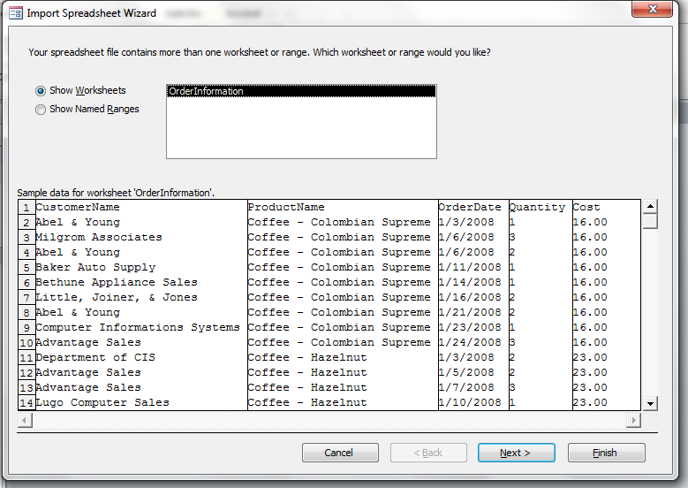

List of sheets present in the excel file will be displayed. Select the appropriate sheet.

1. Check the box ‘First Row contains Column Headings’ and click ‘Next’.

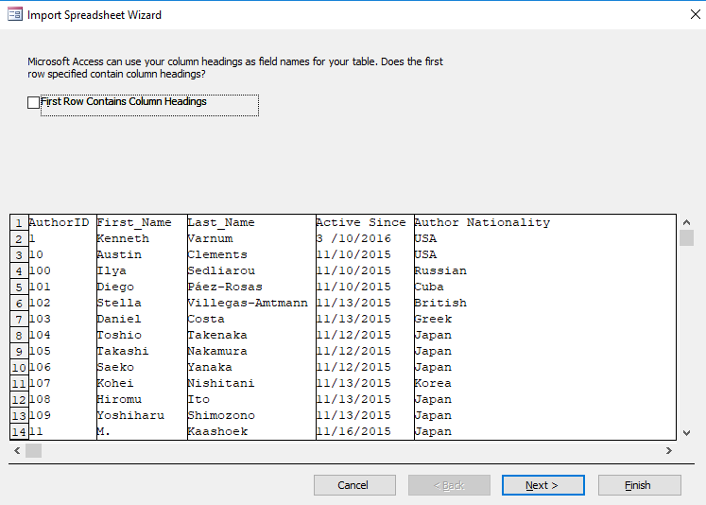

1. This dialog box will show all the fields and its data type. Select each field and check whether it has correct data type or not. **If** the data type is incorrect, change it accordingly by clicking on drop down ‘Data Type’ for that particular field. And then click ‘Next’.

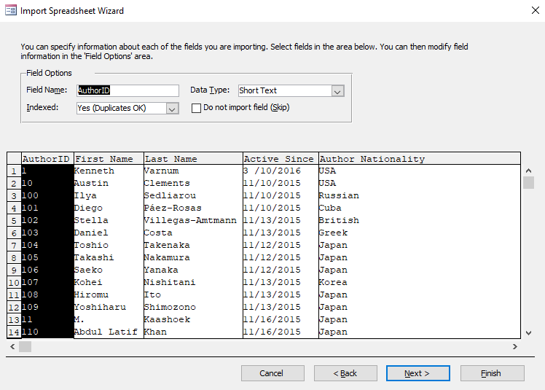

**\*Note: Keep the data type as Short text for fields related to Date. We will change it once import process is done.**

1. Select on radio button ‘Choose my own primary key’ and then select appropriate primary key from the drop down next to the text and click ‘Next’.

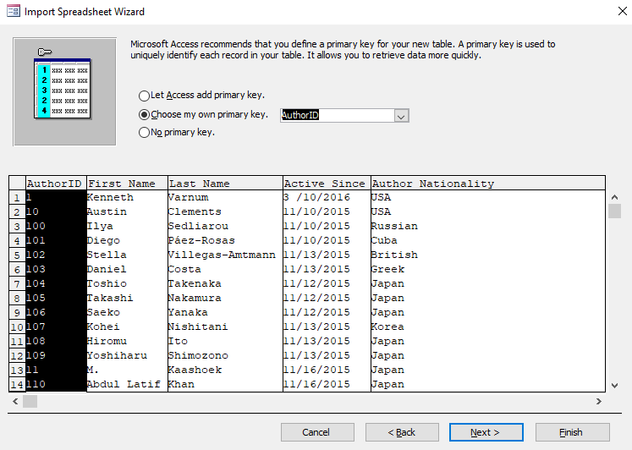

1. Give valid table name and click on ‘Finish’. Then close the wizard. The table will be imported in the access database.

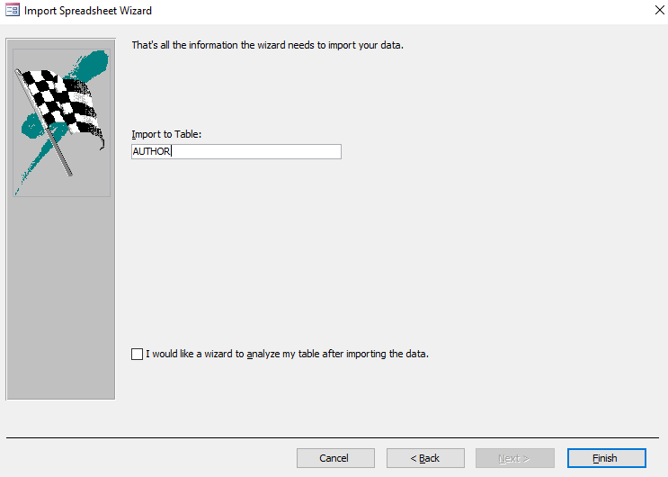

1. If table contains the any field related to **Date**, then go to the design view and change the data type from **‘Short Text’ to ‘Date/Time’**.
2. Check all the data is imported properly and repeat all the steps to import different excel sheets in the access database.
3. Once All the tables are imported, save the database with name Project Four_lastname.accdb
4. Repeat the same steps from 9 for Book2 and Book3.
5. **Write SQL queries Based on the database created in part A**
6. Create a Relationships between all the tables imported in part A as per your understanding.
7. Provide billing details (Invoice number, visitID, date, amount etc..) along with type of appointment for those patients who visited doctor as walk in appointment.
8. Display all the invoice items along with their name and average invoice amount billed for these invoice items in the descending order of the average amount. Only display those items whose average amount is greater than $200
9. Provide billing details (Invoice number, visitID, date, item name and id, amount) for those invoices which are not billed for ‘Lab work’, ‘Pharmacy’ and ‘Office visit’ and whose payment is not made. Also calculate the 7 % interest on the billed amount and display both interest amount as Late Penalty and the new billed amount.
10. Provide maximum bill charged for each of the invoice item whose total insurance is not 0. Display only the maximum billed amount and the invoice item for which the amount is charged.
11. Display all patients (without repetition) had an appointment in February, 2016 and March, 2016.

Rubric:

|  |  |
| --- | --- |
| All 3 tables imported correctly  With correct field name, data type and table name | 9 pts |
| Relationships between tables is created and is correct | 2 pts |
| All the queries executed successfully.  Each query – 3 pts  Have proper field name and all required criteria are met | 15 pts |
| Database, queries saved with correct name | 2 pts |
| No extra queries and table in the database | 2 pts |